Bullets, Lies, and Videotape:
The Amazing, Disappearing Romanian Counter-Revolution of December 1989
by Richard Andrew Hall, Ph.D.

Standard Disclaimer: All statements of fact, opinion, or analysis expressed are those of the author and do not reflect the official positions or views of the Central Intelligence Agency (CIA) or any other U.S. Government agency. Nothing in the contents should be construed as asserting or implying U.S. Government authentication of information or CIA endorsement of the author’s views. This material has been reviewed by CIA to prevent the disclosure of classified information.
I am an intelligence analyst for the Central Intelligence Agency. I have been a CIA analyst since 2000. Prior to that time, I had no association with CIA outside of the application process.

His name was Ghircoias…Nicolae Ghircoias.
And in Romania in December 1989 and January 1990, Nicolae Ghircoias was a very busy man.
We know, officially, of Nicolae Ghircoias’ actions in the last days leading up to the fall of the regime of communist dictator Nicolae Ceausescu on 22 December 1989, as a result of what he and others said at a trial later in January 1990. In bureaucratic parlance, Colonel Nicolae Ghircoias, was the Director of the Criminalistic Institute of the Militia’s [Police’s] General Inspectorate. In colloquial terms, in December 1989 it appears that this amounted to being something of a “cleaner,” or “fixer,” the kind of guy who could make unpleasant things—such as corpses—go away, without leaving a trace.
After regime forces opened fire on anti-regime protesters in the western city of Timisoara on 17 and 18 December 1989, Colonel Ghircoias was dispatched to recover the corpses of those with gunshot wounds from the city’s morgue. The unautopsied cadavers of 43 demonstrators were stolen from the morgue in the dead of night and then transported to the outskirts of the capital Bucharest by refrigerated truck , where they were cremated. Ghircoias was also in charge of collecting and destroying the hospital records and any other incriminating material that might indicate not just the death, but also the life of those who had perished—the official explanation for the disappearance of these citizens was to be that they had fled the country, thus taking their documents with them. In other words, Colonel Nicolae Ghircoias’ job was primarily, it seems, the destruction of evidence.

COLONEL GHIRCOIAS MAKES THE ROUNDS OF BUCHAREST’S HOSPITALS
Unofficially, we also know of Colonel Ghircoias’ exploits after the Ceausescu regime collapsed on 22 December 1989, exploits for which he was not charged at his trial and for which he has never been charged. Of the 1,104 people killed and 3,352 people injured during the December 1989 bloodshed, 942 of them were killed and 2,251 wounded after Nicolae and Elena Ceausescu fled power on 22 December 1989. At the time, personnel of the communist regime’s secret police—known as the Securitate—and allied foreign mercenaries fighting to restore the Ceausescu regime—collectively christened “the terrorists”—were thought to be the primary source behind the post-22 December bloodshed.
It was in this context, that doctors from Bucharest’s various main hospitals recall Colonel Ghircoias’ sudden, unannounced appearances during the last days of December 1989 and first days of January 1990. Professor Andrei Firica of the Bucharest “Emergency Hospital” recounted in a 2004 media interview largely the same details he had conveyed to the press in the summer of 1990. According to Firica, some 15 to 20 suspected terrorists had been interned at the “Emergency Hospital” in varying states of medical distress. He says he made a small file of the medical situations of these patients. A Militia colonel, whom he later was to see in [prisoner] stripes on TV as a defendant in the Timisoara trial—i.e. fairly clearly Ghircoias—came one day and counseled him to keep nosy foreign reporters away from the beds of the “terrorists,” stating ominously that “these were just terrorist suspects and he [Dr. Firica] didn’t want to wake up one day on trial for having defamed someone”! The colonel later came and loaded the wounded terrorist suspects onto a bus and off they went. Firica maintains the files he kept on the terrorist suspects “of course, disappeared.” He noted, however, that he asked his son, who had studied theater and film at university, to film the terrorists tied down to the hospital beds, and he claims he gave copies of this cassette to the Procuracy.
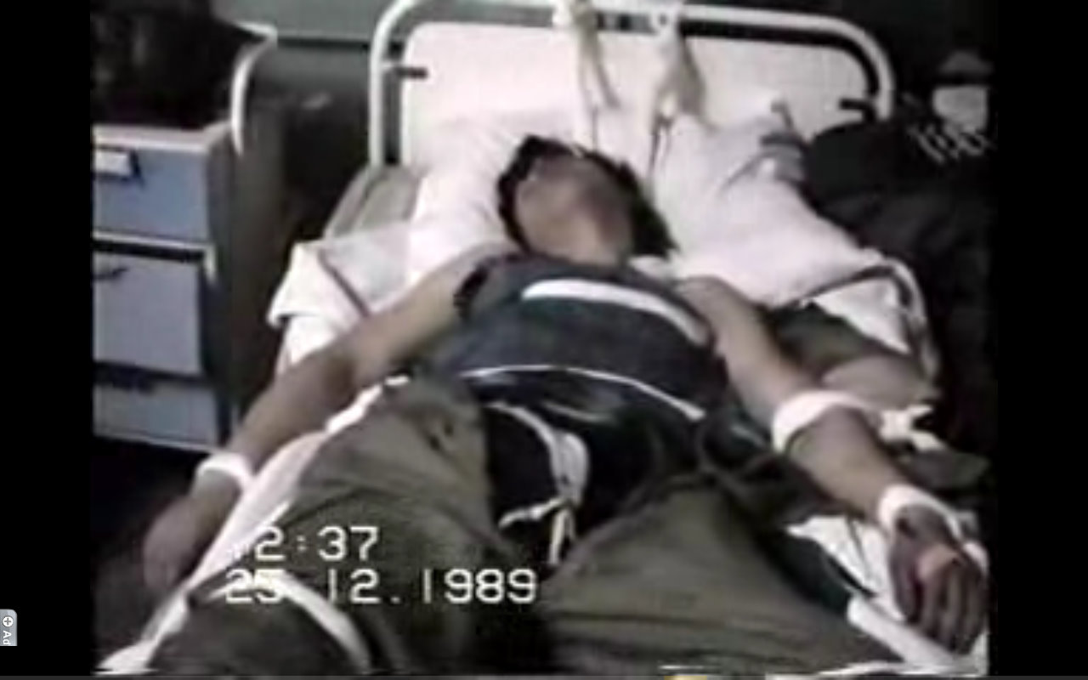

[In viewing these photos, witness what Constantin Fugasin recounted in “Unde ne sint teroristii?” Zig-Zag, in 1990, based in part on an interview with Dr. Andrei Firica:
At the Emergency Hospital 13 suspected of being what we call terrorists were interned. Among these a few were definitely foreign, even though all had Romanian papers. Two clearly had ‘Mongoloid’ (‘Asiatic’) features (one stated that his mother was Romanian, while his father was from Laos), while four others were Arabs. Nevertheless, they spoke Romanian very well. Doctor Nicolae Staicovici, who worked a time in Egypt and who treated them for a time spoke with them. At a moment, he formed a question in Arabic. One of the injured responded to him perfectly. All were well-built, one was a ‘mountain of a man.’ He said nothing, although he probably had terrible pains. There were also two terrorists who were not wounded. One arrived at night, under some pretext. Those on guard suspecting him, immobilized him. He had on three layers of clothing and several ids. They tied him to the stretcher, but although he appeared rather frail, at a given moment he ripped the restraints off.]
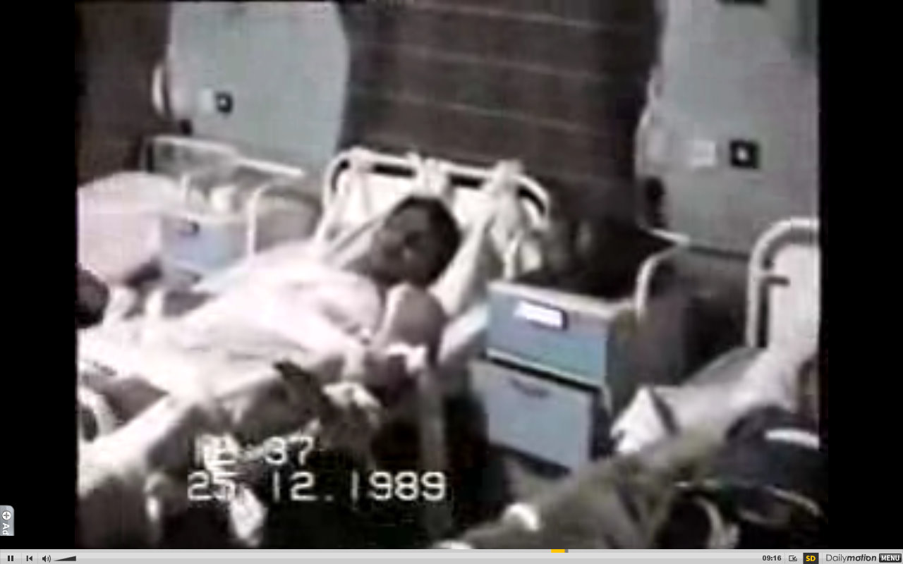
[Dr. Andrei Firica, 2004: From a diagnostic perspective, those who maintain that the terrorists didn’t exist are telling an outrageous lie…In the Emergency Hospital, people were brought who were shot with precision in the forehead, from behind, just a few yards in the crowd of demonstrators, such people who did this can only be called terrorists…]

Dr. Nicolae Constantinescu, chief surgeon at the Coltea Hospital, also was paid the honor of a visit by Colonel Ghircoias during these days:
I remember that on 1 or 2 January ’90 there appeared at the [Coltea] hospital a colonel from the Interior Ministry, who presented himself as Chircoias. He maintained in violent enough language that he was the chief of I-don’t-know-what “criminalistic” department from the Directorate of State Security [ie. Securitate]. He asked that all of the extracted bullets be turned over to him. Thus were turned over to him 40 bullets of diverse forms and dimensions, as well as munition fragments.
To the question of whether he informed the Military Procuracy?
Of course, I announced the Prosecutor’s Office, and requested an investigation [of those shot in the revolution]. For example, when I showed them the apartment from where there were was shooting during the revolution, on the fourth floor of the ‘Luceafarul’ cinema, the prosecutors told me that they sought to verify it and uncovered that there was a Securitate ‘safehouse’ there and that was it.
In 1992, I signed along with other doctors, university professors, renowned surgeons, a memorandum [see page 5 for an article apparently linked to the memorandum] addressed to the Prosecutor General in which we requested an investigation regarding the wounded and dead by gunfire. Not having received any response, after six months I went there to ask what was going on. They told me they were working on it, and they showed me two or three requests and that was it. One of the prosecutors took me into the hallway and told me “I have a child, a wife, it is very complicated.” He asked me what I thought I was doing…I lit back into him, I told him I wasn’t just any kind of person to be blown off.
I showed him the x-rays of those who were shot, I showed him the bullets in the liver. The x-rays exist, they weren’t my invention, I didn’t just dream all this up to demand an investigation! I told them that there are some people who wish to find out the truth and they signed a memo to the Procuracy and they aren’t just anybody, but doctors with experience, experts in the field. In vain, we requested ballistics tests and other research, in vain we presented forms, documents, x-rays, studies. They did not want to undertake a serious investigation.
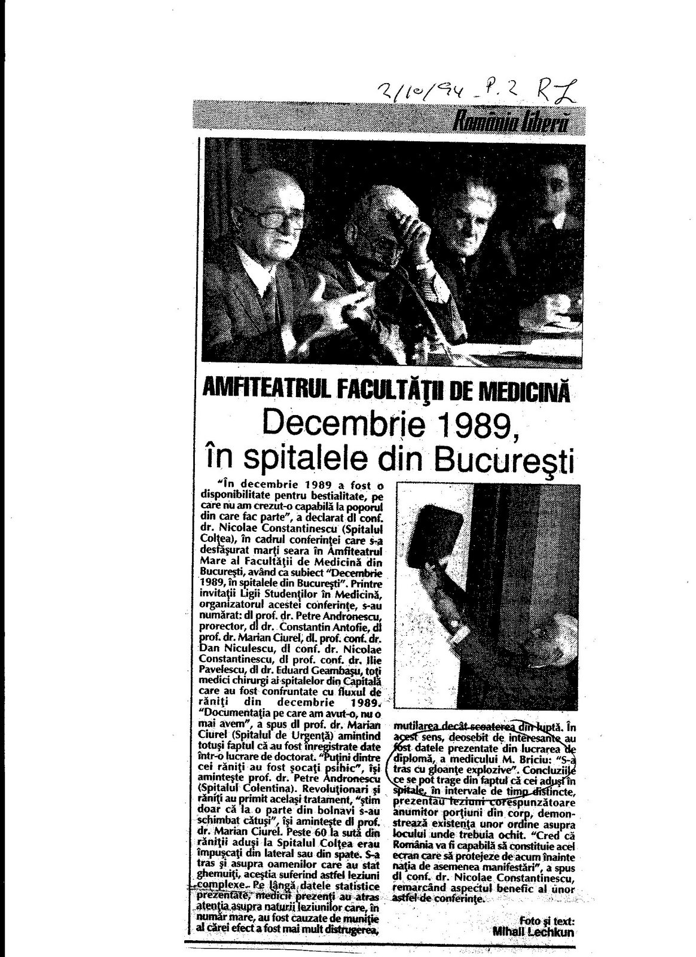
Romania, December 1989: a Revolution, a Coup d’etat, AND a Counter-Revolution
This December marks twenty years since the implosion of the communist regimeof Dictator Nicolae Ceausescu. It is well-known, but bears repeating: Romania not only came late in the wave of communist regime collapse in the East European members of the Warsaw Pact in the fall of 1989 (Poland, Hungary, the GDR, Czechoslovakia, Bulgaria), it came last—and inevitably that was significant. Despite the more highly personalist (vs. corporate) nature of the Ceausescu regime, the higher level of fear and deprivation that characterized society, and the comparative insulation from the rest of the East European Warsaw Pact states, Romania could not escape the implications of the collapse of the other communist party-states. Despite the differences, there simply were too many institutional and ideological similarities, or as is often most importantly the case, that is how members of both the state and society interpreted matters. “Going last” [in turn, in show] almost inevitably implies that the opportunities for mimicry, for opportunism, for simulation on the one hand and dissimulation on the other, are greater than for the predecessors…and, indeed, one can argue that some of what we saw in Romania in December 1989 reflects this.
Much of the debate about what happened in December 1989 has revolved around how to define those events…and their consequences. [These can be analytically distinct categories and depending on how one defines things, solely by focusing on the events themselves or the consequences, or some combination thereof, will inevitably shape the answer one gets]. The primary fulcrum or axis of the definitional debate has been between whether December 1989 and its aftermath were/have been a revolution or a coup d’etat. But Romanian citizens and foreign observers have long since improvised linguistically to capture the hybrid and unclear nature of the events and their consequences. Perhaps the most neutral, cynical, and fatalistic is the common “evenimentele din decembrie 1989”—the events of December 1989—but it should also be pointed out that the former Securitate and Ceausescu nostalgics have also embraced, incorporated and promoted, such terminology. More innovative are terms such as rivolutie (an apparent invocation of or allusion to the famous Romanian satirist Ion Luca Caragiale’s 1880 play Conu Leonida fata cu reactiunea , where he used the older colloquial spelling revulutie) or lovilutie (a term apparently coined by the humorists at Academia Catavencu, and combining the Romanian for coup d’etat, lovitura de stat, and the Romanian for revolution, revolutie).
The following characterization of what happened in December 1989 comes from an online poster, Florentin, who was stationed at the Targoviste barracks—the exact location where Nicolae and Elena Ceausescu would be summarily tried and executed on 25 December 1989. Although his definitions may be too economically-based for my taste—authoritarianism/dictatorship vs. democracy would be preferable—and the picture he presents may be oversimplified at points, the poster’s characterization shows that sometimes the unadorned straighttalk of the plainspoken citizen can cut to the chase better than many an academic tome:
I did my military service, in Targoviste, in fact in the barracks at which the Ceausescu couple were executed…It appears that a coup d’etat was organized and executed to its final step, the proof being how the President of the R.S.R. (Romanian Socialist Republic) died, but in parallel a revolution took place. Out of this situation has transpired all the confusion. As far as I know this might be a unique historical case, if I am not mistaken. People went into the streets, calling not just for the downfall of the president then, but for the change of the political regime, and that is what we call a revolution. This revolution triumphed, because today we have neither communism, nor even neocommunism with a human face. The European Union would not have accepted a communist state among its ranks. The organizers of the coup d’etat foresaw only the replacement of the dictator and the maintenance of a communist/neocommunist system, in which they did not succeed, although there are those who still hope that it would have succeeded. Some talk about the stealing of the revolution, but the reality is that we live in capitalism, even if what we have experienced in these years has been more an attempt at capitalism, orchestrated by an oligarchy with diverse interests...
This is indeed the great and perhaps tragic irony of what happened in December 1989 in Romania: without the Revolution, the Coup might well have failed, but without the Coup, neither would the Revolution have succeeded. The latter is particularly difficult for the rigidly ideological and politically partisan to accept; yet it is more than merely a talking point and legitimating alibi of the second-rung nomenklatura who seized power (although it is that too). The very atomization of Romanian society that had been fueled and exploited by the Ceausescu regime explained why Romania came last in the wave of Fall 1989, but also why it was and would have been virtually impossible for genuine representatives of society—led by dissidents and protesters—to form an alternative governing body on 22 December whose decisions would have been accepted as sufficiently authoritative to be respected and implemented by the rump party-state bureaucracy, especially the armed forces and security and police structures. The chaos that would have ensued—with likely multiple alternative power centers, including geographically—would have likely led to a far greater death toll and could have enabled those still betting on the return of the Ceausescus to after a time reconquer power or seriously impede the functioning of any new government for an extended period.
The fact that the Revolution enabled the coup plotters to seize power, and that the coup enabled the Revolution to triumph should be identified as yet another version—one particular to the idiosyncracies of the Romanian communist regime—of what Linz and Stepan have identified as the costs or compromises of the transition from authoritarian rule. In Poland, for example, this meant that 65 percent of the Sejm was elected in non-competitive elections, but given co-equal authority with the Senate implying that “a body with nondemocratic origins was given an important role in the drafting of a democratic constitution”; in fact, Poland’s first completely competitive elections to both houses of Parliament occurred only in October 1991, fully two years after the formation of the first Solidarity government in August 1989. In Romania, this meant that second-rung nomenklaturists—a displaced generation of elites eager to finally have their day in the sun—who to a large extent still harbored only Gorbachevian perestroikist views of the changes in the system as being necessary, were able to consolidate power following the elimination of the ruling Ceausescu couple.
The self-description by senior Front officials (Ion Iliescu) and media promoters (such as Darie Novaceanu in Adevarul) of the FSN (National Salvation Front) as the “emanation of the Revolution” does not seem justified. It seems directly tied to two late January 1990 events—the decision of the Front’s leaders to run as a political party in the first post-Ceausescu elections and the contestation from the street of the Front’s leaders’ legitimacy to rule and to run in those elections. It also seems difficult to defend objectively as a legitimate description, since even according to their own accounts, senior Front officials had been in contact with one another and discussed overthrowing the Ceausescus prior to the Revolution, since there had existed no real competing non-Ceausescu regime alternative on 22 December 1989 (an argument they themselves make), and since they had clearly not been elected to office. Moreover, when senior former Front officials, Iliescu among them, point to their winning of two-thirds of the votes for the new parliament in May 1990 and Iliescu’s 85 percent vote for the presidency, the numbers in and of themselves—even beyond the by now pretty obvious and substantiated manipulation, surveillance, and intimidation of opposition parties, candidates, movements and civil society/non-governmental organizations that characterized the election campaign—are a red flag to the tainted and only partly free and fair character of those founding elections.
But if the FSN and Ion Iliescu cannot be accurately and legitimately described as the “emanation of the Revolution,” it also seems reasonable to suggest that the term “stolen revolution” is somewhat unfair. The term “stolen revolution” inevitably suggests a central, identifiable, and sufficiently coherent ideological character of the revolution and the presence of an alternative non-Ceausescu, non-Front leadership that could have ensured the retreat of Ceausescu forces and been able to govern and administer the country in the days and weeks that followed. The absence of the latter was pretty clear on 22 December 1989—Iasi, Timisoara, and Arad among others, had local, authentic nuclei leading local movements (for example, the FDR, Frontul Democrat Roman), but no direct presence in Bucharest—and the so-called Dide and Verdet “22 minute” alternative governments were even more heavily compromised by former high-ranking communist dignitary inclusion than the FSN was (the one with the least, headed by Dumitru Mazilu, was rapidly overtaken and incorporated into the FSN).
As to the question of the ideological character of the revolt against Ceausescu, it is once again instructive to turn to what a direct participant, in this case in the Timisoara protests, has to say about it. Marius Mioc, who participated in the defense of Pastor Tokes’ residence and in the street demonstrations that grew out of it, was arrested, interrogated, and beaten from the 16th until his release with other detainees on the 22nd and who has written with longstanding hostility toward former Securitate and party officials, IIiescu, the FSN, and their successors, gives a refreshingly honest account of those demonstrations that is in stark contrast to the often hyperpoliticized, post-facto interpretations of December 1989 prefered by ideologues:
I don’t know if the 1989 revolution was as solidly anticommunist as is the fashion to say today. Among the declarations from the balcony of the Opera in Timisoara were some such as “we don’t want capitalism, we want democratic socialism,” and at the same time the names of some local PCR [communist] dignitaries were shouted. These things shouldn’t be generalized, they could have been tactical declarations, and there existed at the same time the slogans “Down with communism!” and flags with the [communist] emblem cut out, which implicitly signified a break from communism. [But] the Revolution did not have a clear ideological orientation, but rather demanded free elections and the right to free speech.

Romania December 1989 was thus both revolution and coup, but its primary definitive characteristic was that of revolution, as outlined by “Florentin” and Marius Mioc above. To this must be added what is little talked about or acknowledged as such today: the counter-revolution of December 1989. Prior to 22 December 1989, the primary target of this repression was society, peaceful demonstrators—although the Army itself was both perpetrator of this repression but also the target of Securitate forces attempting to ensure their loyalty to the regime and their direct participation and culpabilization in the repression of demonstrators. After 22 December 1989, the primary target of this violence was the Army and civilians who had picked up weapons, rather than citizens at large. It is probably justified to say that in terms of tactics, after 22 December 1989, the actions of Ceausist forces were counter-coup in nature, contingencies prepared in the event of an Army defection and the possibility of foreign intervention in support of such a defection. However, precisely because of what occurred prior to 22 December 1989, the brutal, bloody repression of peaceful demonstrators, and because the success of the coup was necessary for the success of the revolution already underway, it is probably accurate to say that the Ceausescu regime’s actions as a whole constituted a counter-revolution. If indeed the plotters had not been able to effectively seize power after the Ceausescus fled on 22 December 1989 and Ceausescu or his direct acolytes had been able to recapture power, we would be talking of the success not of a counter-coup, but of the counter-revolution.
A key component of the counter-revolution of December 1989 concerns the, as they were christened at the time, so-called “terrorists,” those who were believed then to be fighting in defense of the Ceausescu couple. It is indeed true as Siani-Davies has written that the Revolution is about so much more than “the Front” and “the terrorists.” True enough, but the outstanding and most vexing question about December 1989—one that resulted in 942 killed and 2,251 injured after 22 December 1989—is nevertheless the question of “the terrorists.” Finding out if they existed, who they were, and who they were defending remains the key unclarified question of December 1989 two decades later: that much is inescapable.

“LOST”…DURING INVESTIGATION: WHEN ABSENCE OF EVIDENCE IS NOT EVIDENCE OF ABSENCE.
From early in 1990, those who participated in or were directly affected by the December 1989 events have attested to efforts to cover-up what happened. Significantly, and enhancing the credibility of these accusations, those who claim such things come from diverse backgrounds, different cities, and from across the post-Ceausescu political spectrum. Further enhancing their credibility, in many cases, they do not attempt to place these incidents into larger narratives about what happened in December 1989, but merely note it as a fact in relating their own personal experiences.
Let’s take the case of Simion Cherla, a participant in the December 1989 events in Timisoara. Here is how Radu Ciobotea recounted Cherla’s story in May 1991:
Simion Cherlea also arrives, agitated. He received a death threat, wrapped in a newspaper. Next to it, in his mailbox, a bullet cartridge was also found. To suggest to him that that is how he would end up if…
--If I talk. Or if I have a copy of the file that I removed on 22 December 1989 from the office of the head of the county Securitate. There was a map of the 8 Interior Ministry formations from Timisoara and “registry-journal of unique ordered operational activities.” I gave them to Constantin Grecu (since transferred to the reserves), who gave them to Colonel Zeca and General Gheorghe Popescu. These documents were of great use…in the Army’s fight against the terrorists.
--Do you know what the deal is with such formations?...When I looked at the map, my eyes glazed over. Their formations were for entire zones where 10 to 12 nests of gunfire were programmed to shoot at a precise hour and minute! Can you imagine! And I, because I was trying to help in the fight against the terrorists, I turned it over to them! So now I asked for it to be used at the trial. In the registry everything was written: who ordered, who executed the mission, the place, the hour, how long it last, the impact. Great, all these documents are now said to have disappeared. And I am threatened that I too will disappear like them.
The discovery and then disappearances of such maps showing the placement and actions of Interior Ministry units—in particular, the Securitate—was recounted by others in the early 1990s.
Nor, as we saw earlier from Dr. Nicolae Constantinescu’s testimony above, could one count on the military prosecutor’s office. Jean Constantinescu [no apparent relation], who was shot in the CC building on 23 December 1989, stated the following in a declaration he gave just last year (as recounted by the investigative journalist Romulus Cristea):
I had two encounters with representatives from the prosecutor’s office. The first prosecutor visited me at home, around two months after the events, he listened and noted my account, and as a conclusion, informally, he said something to me such as “we already know a good part of the shooters, they can be charged and pay civil damages, you can be part of the lawsuit and request appropriate damages.” After hesitating, I added such a request, at the end of my written declaration, which I signed….
The second prosecutor, who later came to head the institution [the procuracy], invited me after several months to the office near Rosetti Square. At the end of the conversation, he attempted to convince me that we shot amongst ourselves [ie there was no real enemy, no terrorists].
The second prosecutor’s actions, according to Constantinescu’s recounting, are very familiar. Already in mid-January 1990, participants in the gunfights of Brasov were telling the press that important evidence was missing and that the former Securitate were attempting to change the story of December 1989:
Florin Crisbasan: Now the securisti are spreading their version: “You guys shot into one another like a bunch of idiots.”…About 100 people were arrested as terrorists, but now they tell us they no longer have them…documents are missing, they don’t know how or what type: a video cassette that I wished to access, with film from the events, can no longer be found….
Emil Ivascu: If they tell us that “we shot among ourselves,” how the hell do you explain the ammunition with which they [the terrorists] fired? A bullet would rip your foot apart. We saw for ourselves these type of arms. Could just average civilians have been in possession of these?
In May 1991, Gheorghe Balasa and Radu Minea described in detail for journalist Dan Badea the atypical ammunitions they found in the headquarters of the Securitate’s Vth Directorate (charged with Ceausescu’s personal security) building, including dum-dum bullets and special bullets (apparently vidia bullets). They noted the civilians and soldiers who had witnessed this find, and mentioned that a certain Spiru Zeres had filmed the whole sequence, cassettes that were available for the military procuracy.
Journalist and documentary-maker Maria Petrascu, who with her since deceased husband Marius, had for years investigated the Brasov events, also drew attention to the type of ammunition used in December 1989 when she recalled in 2007 that, “For a long time the Brasov Military Procuracy didn’t do anything, although they had evidence, statements, documents, photos and even the atypical bullets brought by the families of those killed or wounded.” A soldier shot on 23 December 1989 in Buzau recently admitted that his doctors changed their declarations regarding the bullet with which he had been hit—identified by another soldier with whom he was interned as a ‘vidia’ bullet—to standard 7.62 mm ammunition. In fall 2006, the daughter of a priest recalled:
In December ’89, after he arrived from Timisoara, my father stayed with me on Stefan Cel Mare Boulevard [in Bucharest]. We returned to our home, on the corner of Admiral Balescu and Rosenthal. I found the cupboard of the dresser pure and simple riddled with bullets, about 8 to 10 of them. Someone who knew about such things told me they were vidia bullets. They were brought to a commission, but I don’t know what happened to them.
This echoes something that Army Colonel Ion Stoleru was saying back in 1992: that the “terrorists” had “weapons with silencers, with scopes, for shooting at night time (in ‘infrared’), bullets with a ‘vidia’ tip. Really modern weapons,” to which he added, significantly, “The civilian and military commissions haven’t followed through in investigating this…”
And yet, amazingly—despite all these testimonies regarding the existence and use of atypical munitions, or perhaps better put, precisely because of them—as of August 1991, Rasvan Popescu could report that “of the thousands of projectiles shot against the revolutionaries during December 1989, the Prosecutor’s office has entered into the possession of…four bullets. A ridiculous harvest.”

BANKING ON THE ABSENCE OF EVIDENCE…
If Rasvan Popescu’s account is correct, it is understandable why functionaries of the Ceausescu regime have long banked on an absence of evidence. For example, when asked if other than the standard 7.62 mm caliber weapons belonging to the Army were used in December 1989, Dr. Vladimir Belis, the head of the Institute of Forensic Medicine (IML) at the time, claims he doesn’t know and can’t say, because he claims no autopsies were ever performed—leading journalists to conclude that “therefore the tales of terrorists who shot with ‘dum-dum’ bullets, ‘bullets with vidia tips’ or bullets of large caliber, atypical for Romanian military units, will remain just stories that can neither be confirmed nor denied.”
Former Securitate officer-turned journalist, novelist, and celebrity, Pavel Corut, has written alternatively derisively and sarcastically—well-nigh tauntingly—about the existence of such atypical ammunition and its use in December 1989:
“…Later I read fantastical and pathetic accounts according to which this [Army] officer died by being ‘hit by vidia and explosive [dum-dum] bullets.’ It isn’t the only case of a solider killed accidentally in warfare…”
“Now we know that all the information…was false: there did not exist a special guard unit that pledged an oath of (legionary-like) fealty to the dictator, there did not exist snipers with infrared sighting systems, no one shot vidia bullets…”
“Vidia bullets don’t exist anywhere in the world. And yet even the Army believed that the ‘Securitate-terrorists’ used vidia bullets….All this information was designed to create [the impression of] terrorists. To show the people and the whole world fanatical terrorists.”
Last, but hardly least, military prosecutors with roots in the Ceausescu era, have assimilated or mirror such arguments. General Dan Voinea who headed the investigations from 1997-2001 and 2004-2008 said as much:
Romulus Cristea (journalist): “Did special ammunition, bullets with a vidia tip or dum-dum bullets, claim [any] victims? The press of the time was filled with such claims…”
Dan Voinea: There were no victims (people who were shot) from either vidia bullets or dum-dum bullets. During the entire period of the events war munitions were used, normal munitions that were found at the time in the arsenal of the Interior Ministry and the Defense Ministry. The confusion and false information were the product of the fact that different caliber weapons were used, and therefore, the resulting sound was perceived differently. (Emphasis added)
The wonderful legalistic (alibi-bestowing) logic for Voinea and his colleagues then goes something like this: there exist victims requesting damages for injuries, loss of life, livelihood or property sustained during the violence of December 1989, their loss was real and deserves to be compensated by the Romanian state; but those initially considered guilty of causing much of this injury, loss of life, and damage and taken into custody in December 1989—the”terrorist” suspects—were released in January 1990, and so juridically there do not exist defendants; nor does there appear to still exist in the hands of the military procuracy much of the material evidence presented in 1990-1991—maps, videos, etc.—and, apparently, only four bullets; and no autopsies were officially performed on those shot in December 1989. So in essence, the only things left are the crimes themselves and the testimonies of those interviewed over the past two decades: no autopsy records, little material evidence, and the original suspects have gone missing…Conclusion: no atypical munitions existed, were used, or maimed or killed anybody, and there were no terrorists, everyone shot into everyone else in the chaos of the moment—or in other words, the exact argument which as we have seen has been with us since Florin Crisbasan and Emil Ivascu of Brasov related the former Securitate’s “line of reasoning” in mid-January 1990.

VIDEO KILLED THE DICTATOR…AND EXPLODES THE LIES OF HIS SUBORDINATES:
Four Videos in the Battle against Amnesia and Denial
For years, former Securitate and Militia personnel, and senior former communist party officials—in other words those most vested in the former Ceausescu regime and its legacy—have banked on the fact that the material evidence that could contradict their claims was absent, in fact did not and had never not existed. As a result of the odd twists, turns, and vagaries of post-Ceausescu politics—combining rigidly partisan political narratives with a remarkable permeability to the arguments and information of “the enemy of my enemy”—it is also the case, ironically, that many on the liberal, anti-communist side of political spectrum, have become vested in this assumption too.
Before the advent in the mid and late 2000s of user-generated content video sites, much of what had been seen of the Revolution came from the studios and cameras of Romanian Television or foreign networks. The Internet and video sites such as Youtube, Daily Motion, and others have broken down the centralized control of other often individually-recorded images, ultimately challenging the sort of control over information exercised by a state agency such as, in this case, the military procuracy.
Video No. 1: Bucharest, Securitate Archives in the Central Committee Building, Dum-Dum and Vidia Bullets
In the first video (posted by Alexandru2006 at http://www.dailymotion.com/video/x7rojm_revolutia-romana-22-dec-1989-cd5_shortfilms) , the sequence from roughly 1:20 to 2:50 shows civilians in the bowels of the CC building in Bucharest—the focal point of the December events, from where Nicolae Ceausescu gave his famous “final speech” on 21 December and from which Front leaders addressed crowds on 22 December and after—showing the munitions found in the Archives of the PCR’s CC. The “dum-dum” bullets of “the elite shooters/commandos”—he mentions they are of West German manufacture—are identified for the camera, as are smaller, special bullets—which appear, based on other video, photos, and accounts, to be “vidia” bullets. [Following the two screen captures below is an article from 31 December 1989, “Cu ce trag teroristii?” (With What are the Terrorists Shooting), in which the journalist discusses having a West German-manufactured (RWS firm) “dum-dum” bullet in his hand, as well as the “unfortunately now-famous small bullets of 5,62 mm caliber” (vidia bullets).]
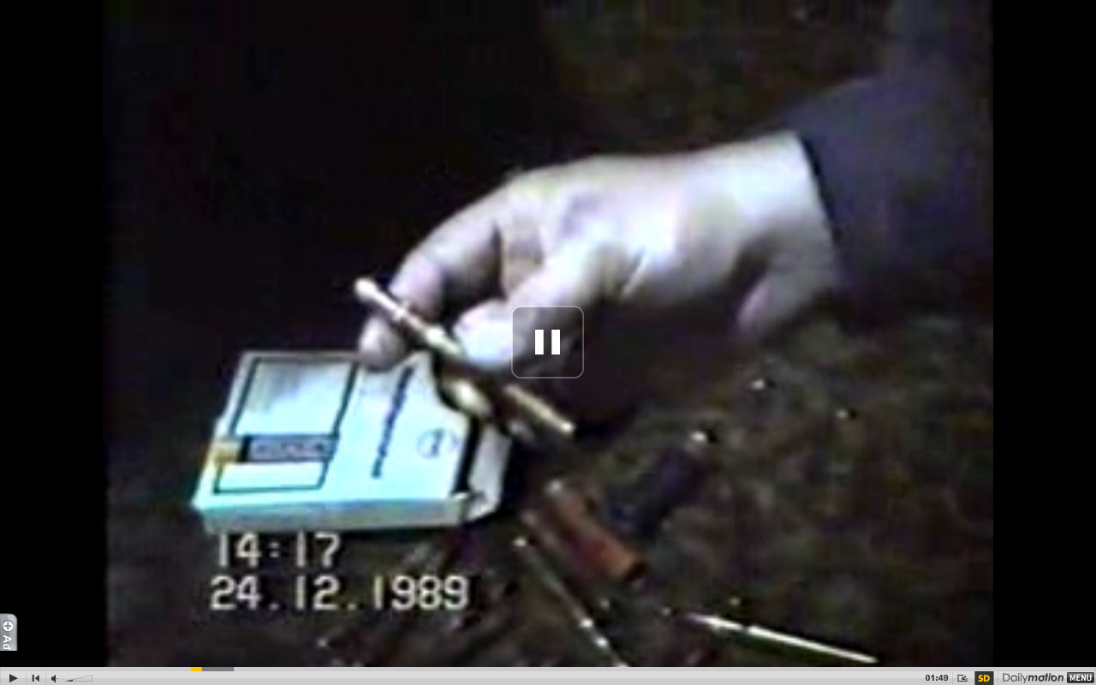
DUM-DUM MUNITIONS OF THE SECURITATE’S ELITE SNIPERS (above); VIDIA BULLETS (below)
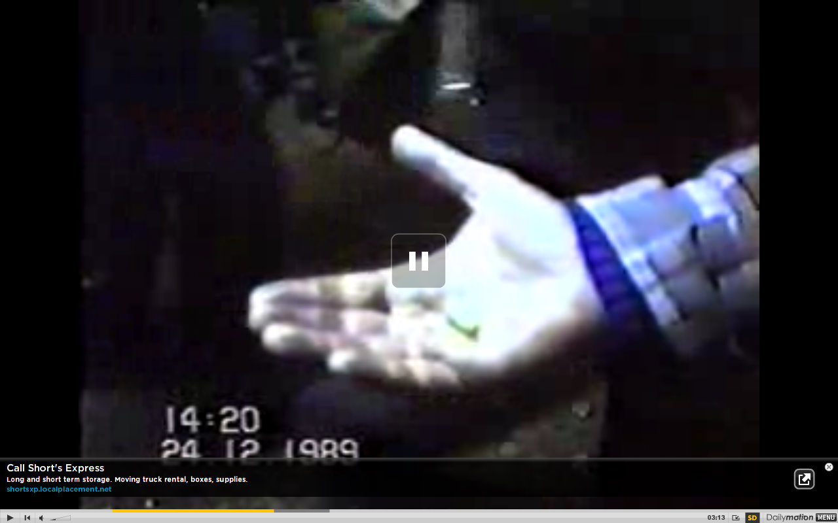

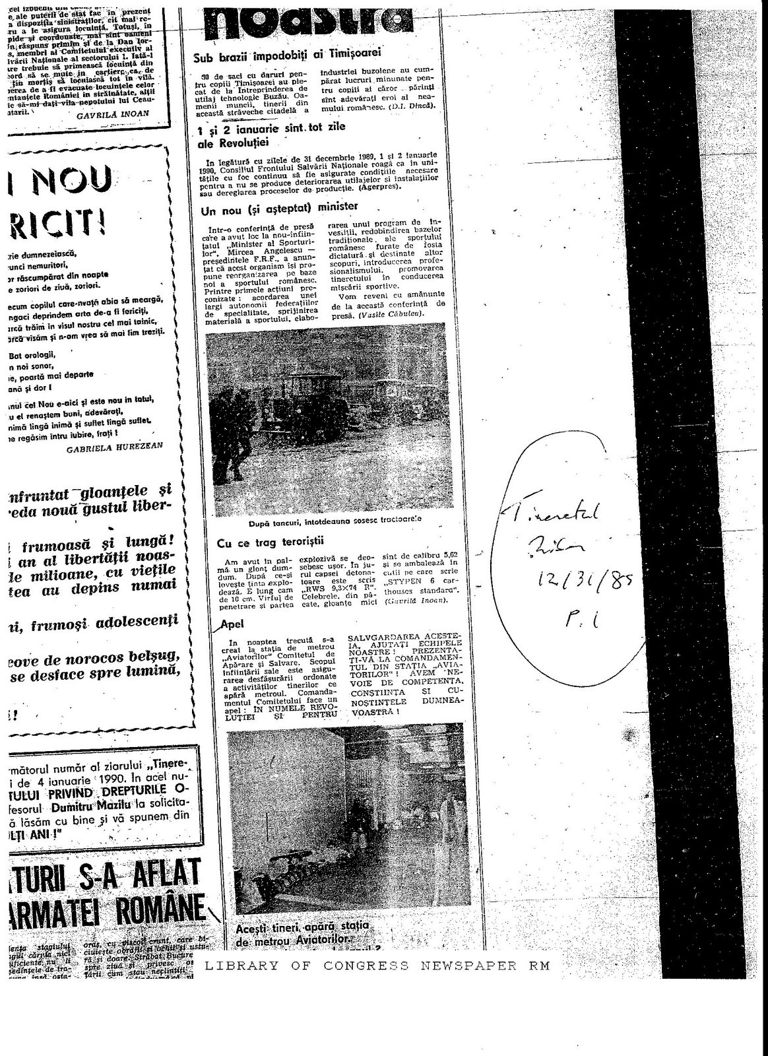
Video No. 2: Bucharest, Piata Aviatorilor, near TVR (Romanian state Television) headquarters, Vidia Bullets
In the second video (posted by Alexandru2006 at http://www.dailymotion.com/video/x7rob0_revolutia-romana-22-dec1989-cd4_shortfilms), a civilian shows how the bullets shot by “the enemy”—i.e. “the terrorists”—are different than the standard ammunition (7.62 mm) he and the others are using. Based on other video, photos, and accounts, these appear to be “vidia” bullets—there are many testimonies from those who fought in the area near the TV station regarding these bullets. [Below the screen capture: a photo posted on the Internet by Alexandru Stepanian, that he claims is a photo of one of these vidia bullets]

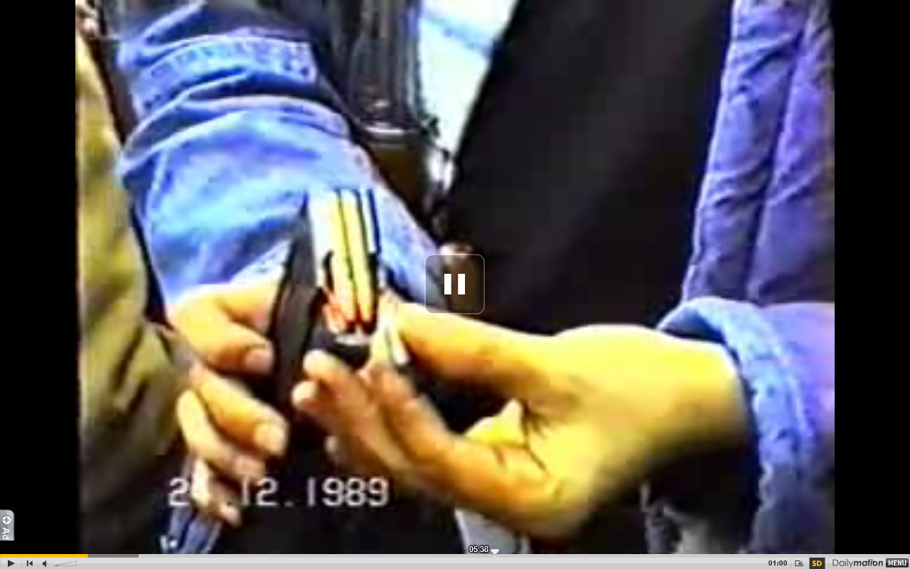
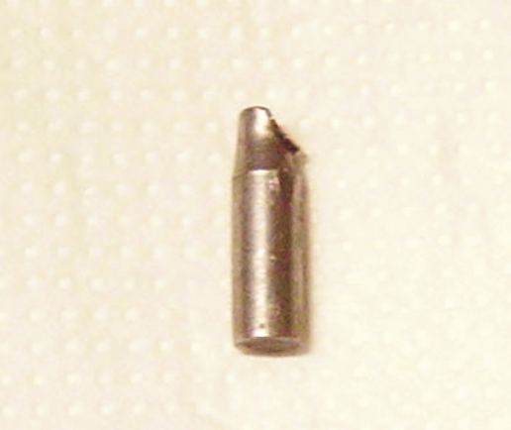
Imaginea a glontului vidia de 5,6 mm, tras la poarta din Pangrati a sediului TVR, in 22-23 decembrie 1989, de tineri vlajgani, in blugi, prinsi, dar eliberati de tov. General Tudor, activat de tov. Ion Iliescu.
Material primit de la dl. Alexandru Stepanian.
www.portalulrevolutiei.ro, glont vidia, zona TVR, Alexandru Stepanian
Video No. 3: Bucharest, Soft-nosed (“Dum-Dum”) Bullets Found in the Headquarters of the Securitate’s V-th Directorate
The third video was found by the blogger who goes by the handle “Claude 2.0” (Claude 2.0 Dupa 19 ani – Gloante dum-dum ? postare din 14 aprilie 2009). It shows people going through material including bullets found in the headquarters building of the Securitate’s Fifth Directorate (that charged with the personal protection of the Ceausescus). An article from March 1990 appended below has a senior arms specialist discussing his being summoned during these days to the zone around the CC building (where the Vth Directorate building was located), where he verified that “soft-nosed” bullets (known colloquially as “dum-dum”) were discovered (he then goes into detail about their properties). Discussion in the videotape about the box in which the bullets were discovered, as well as the comments of the arms specialist, suggest these were Kynoch-Magnum “soft-nosed” bullets—described in the article as “cartridges for [hunting] elephants.”
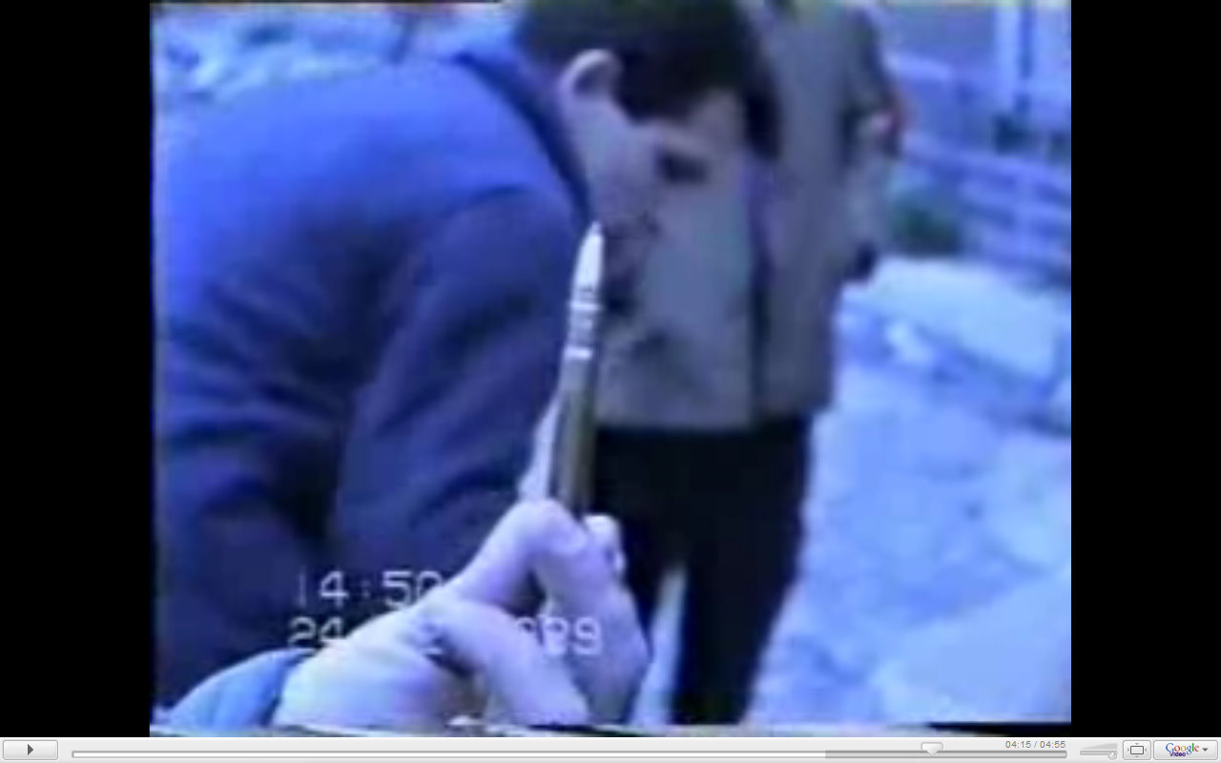

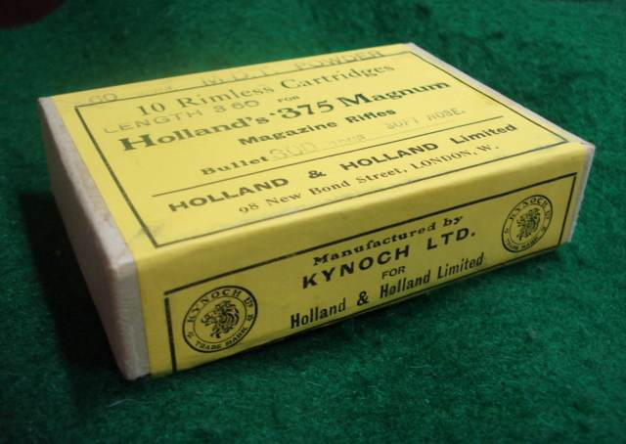
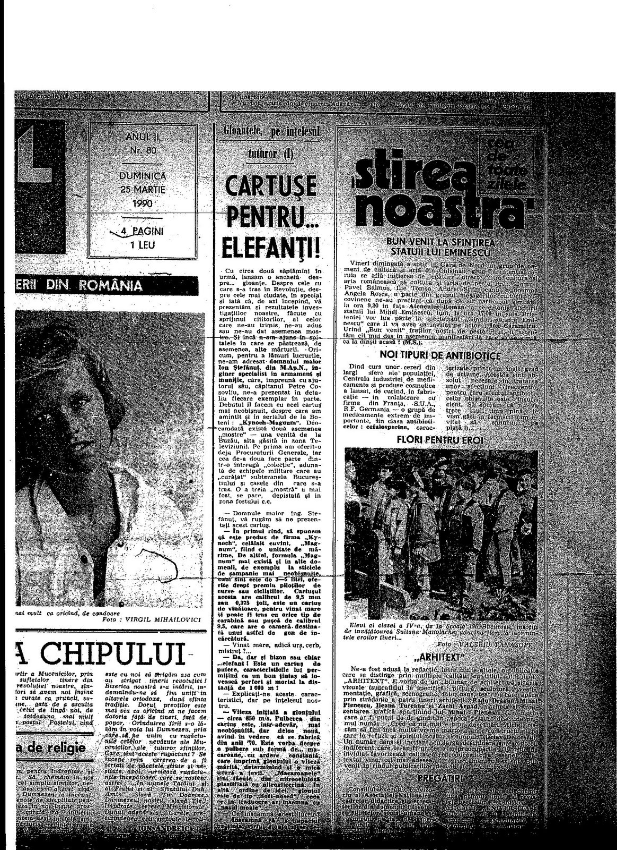
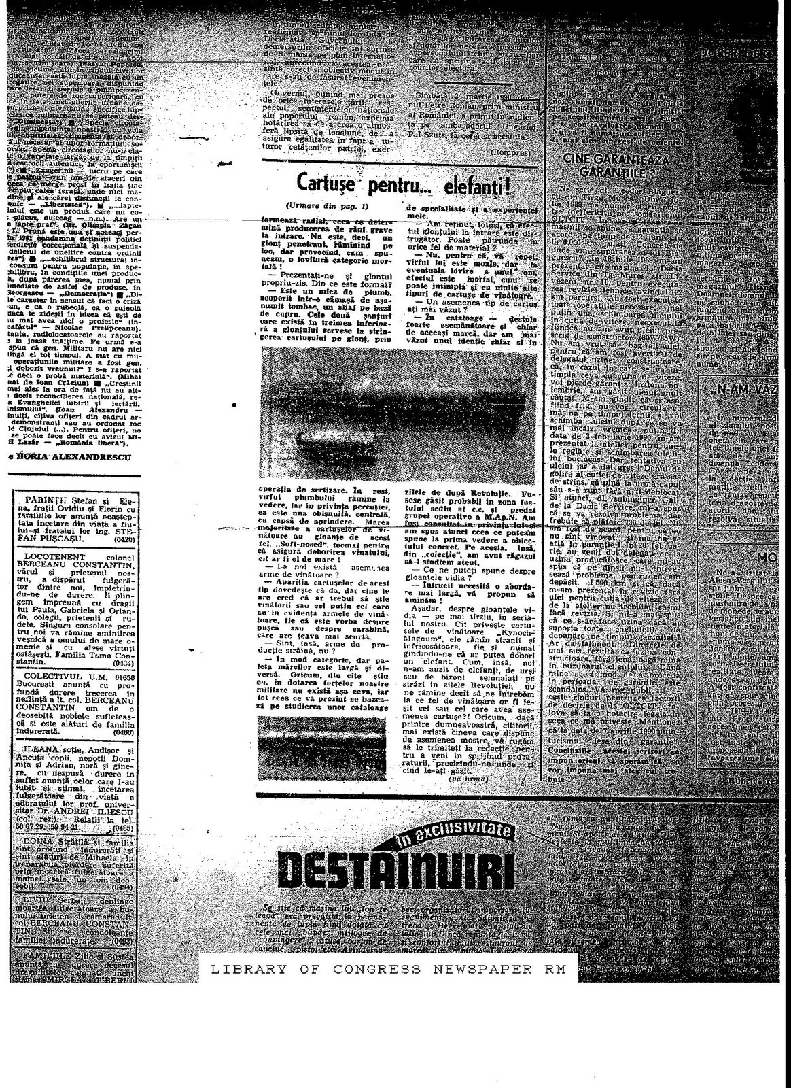Video No. 4: Brasov, Morgue, Atypical (“Vidia”) Bullets
Video 4 comes from part 7 of Maria Petrascu’s 2005 documentary film “Revolutionary Brasov” (Brasovul Revolutionar PARTEA 7 http://www.youtube.com/watch?v=P9z4wLuma0Q). It shows both the small, atypical, [“vidia”] bullets with which civilians and soldiers were killed, as well as an unidentified doctor speaking on 23 January 1990 in which he states that four of six soldiers he had looked at had been shot with great precision in the forehead with such bullets (film is also shown of their gruesome injuries). Maria Petrascu has described elsewhere what she and her husband found on 29-30 December 1989 at the County Morgue:
Even the halls were filled with the dead, there were over 100. They didn’t have any place to put them all, we walked through pools of blood, we saw the cadavers of children, young people, adults, shot in the forehead, in the heart, in the feet and abdomen with brains and intestines having exploded, nightmarish scenes that I shall never forget. It was then that we decided we wouldn’t rest until we discovered who fired, because we had begun to understand that many of those killed had been shot by guns with infrared scopes, by some professionals.
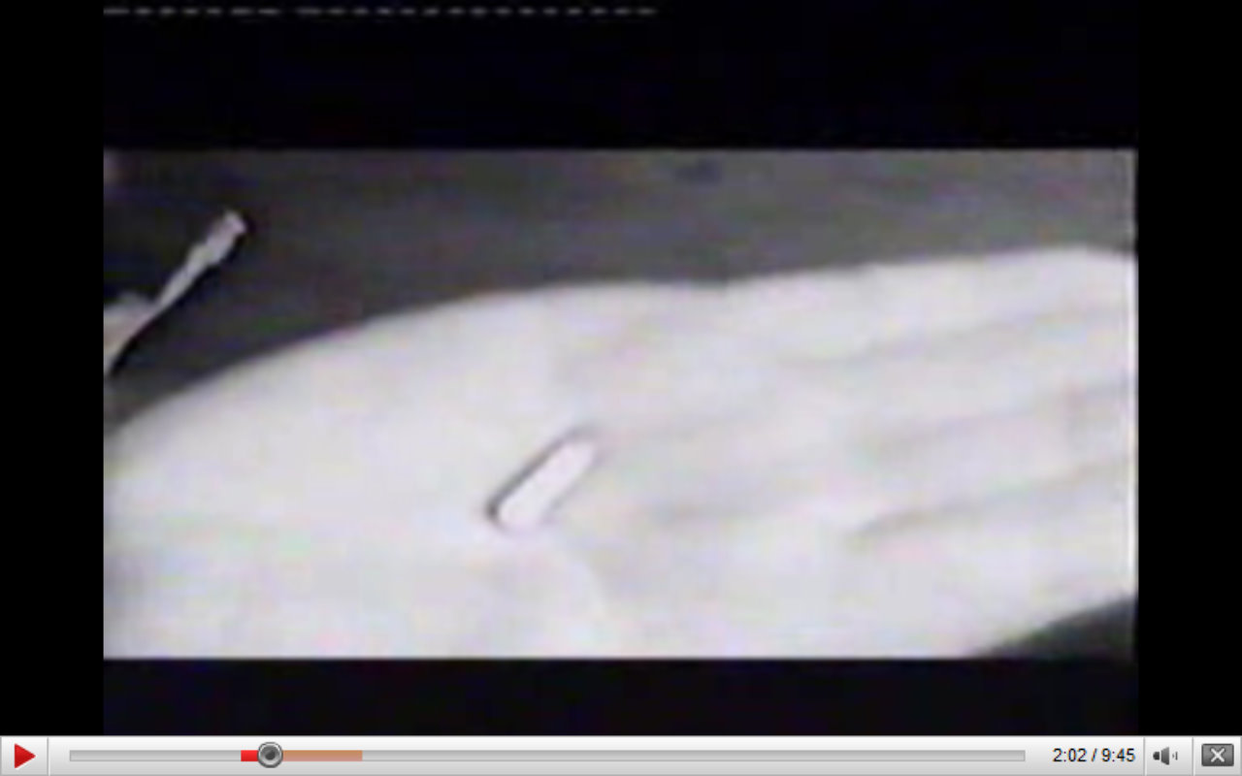
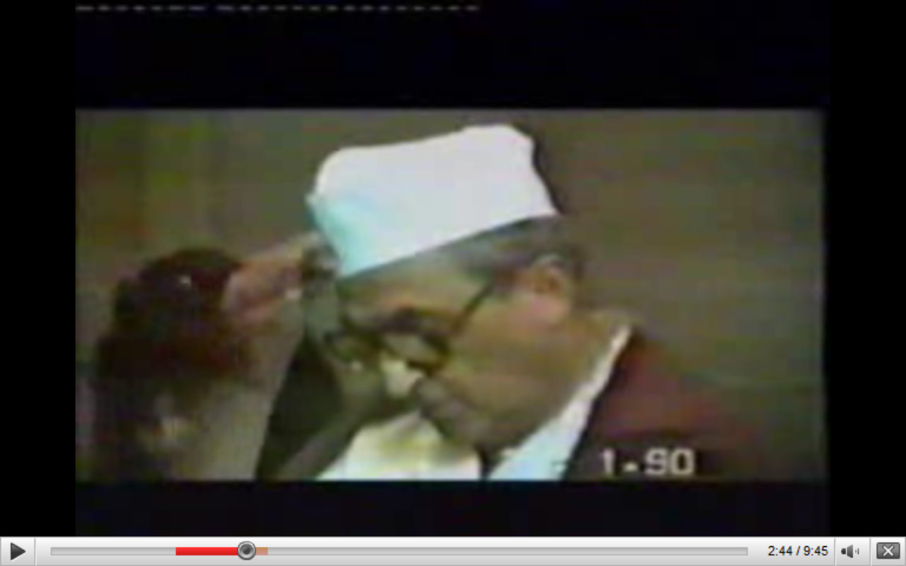

Those Who Have Told Us the Truth
As opposed to the aforementioned Vladimir Belis, Pavel Corut, and Dan Voinea, all of whom who have strenuously and repeatedly denied the existence and use in December 1989 of atypical munitions of dum-dum bullets and vidia bullets, there exist those who have told us of the existence and use of these in December 1989. They are essentially, for lack of a better term, former Securitate whistleblowers, who have admitted the Securitate’s role in providing the “terrorists” who caused so much destruction, mayhem, and loss of life in those days.
For years I have been essentially the sole researcher inside or outside the country familiar with and promoting the claims of 1) former Timisoara Securitate Directorate I officer Roland Vasilevici—who published his claims about December 1989 under the byline of Puspoki F. in the Timisoara political-cultural weekly Orizont in March 1990 and under the pseudonym “Romeo Vasiliu”—and 2) an anonymous USLA recruit who told his story to AM Press Dolj (published on the five year anniversary of the events in Romania Libera 28 December 1994…ironically (?) next to a story about how a former Securitate official attempted to interrupt a private television broadcast in which Roland Vasilevici was being interviewed in Timisoara about Libyan involvement in December 1989).
Vasilevici claimed in those March 1990 articles and in a 140 page book that followed—both the series and the book titled Pyramid of Shadows—that the USLA and Arab commandos were the “terrorists” of December 1989. What is particularly noteworthy in light of the above discussion about “exploding [dum-dum] bullets” was his claim that the USLA and the foreign students who supplemented them “used special cartridges which upon hitting their targets caused new explosions” [emphasis added]—in other words, exploding or dum-dum bullets.
The anonymous USLA recruit stated separately, but similarly:
I was in Timisoara and Bucharest in December ’89. In addition to us [USLA] draftees, recalled professionals, who wore black camouflage outfits, were dispatched. Antiterrorist troop units and these professionals received live ammunition. In Timisoara demonstrators were shot at short distances. I saw how the skulls of those who were shot would explode. I believe the masked ones, using their own special weapons, shot with exploding bullets. In January 1990, all the draftees from the USLA troops were put in detox. We had been drugged. We were discharged five months before our service was due to expire in order to lose any trace of us. Don’t publish my name. I fear for me and my parents. When we trained and practiced we were separated into ‘friends’ and ‘enemies.’ The masked ones were the ‘enemies’ who we had to find and neutralize. I believe the masked ones were the ‘terrorists’. [emphases added]
As I have pointed out, despite the short shrift given these two revelations by Romanian media and Romanianists, one group has paid close attention: the former Securitate. That is not accidental.
Those discussed as alternatively “commandos” or “professionals” appear to have been members of the so-called USLAC—Special Unit for Anti-terrorist and Commando Warfare. In 1991, Dan Badea summarized former USLA Captain Marian Romanescu’s description of the USLAC as follows:
THE USLAC COMMANDOS:
Those who had and have knowledge about the existence and activities of the shock troops subordinated directly to Ceausescu remained quiet and continue to do so out of fear or out of calculation. Much has been said about individuals in black jumpsuits, with tattoos on their left hand and chest, mercenary fanatics who acted at night, killing with precision and withdrawing when they were encircled to the underground tunnels of Bucharest. Much was said, then nobody said anything, as if nothing had ever happened.
Traversing the [Securitate’s] Fifth Directorate and the USLA, the USLAC commandos were made up of individuals who ‘worked’ undercover at different posts. Many were foreign students, doctoral students and thugs committed with heart and soul to the dictator. Many were Arabs who knew with precision the nooks and crannies of Bucharest, Brasov and other towns in Romania. For training these had at their disposal several underground centers of instruction: one was in an area near Brasov, while another—it appears—was right under the former headquarters of the PCR CC [communist party central committee building], a shooting range that was—discovered by accident by several revolutionaries during the events of December .”
We also know from Romanescu and a second source that USLA commander Gheorghe Ardeleanu (Bula Moise) addressed his troops as follows:
“On 25 December at around 8 pm, after the execution of the dictators, Colonel Ardeleanu gathered the unit’s members into an improvised room and said to them:
‘The Dictatorship has fallen! The Unit’s members are in the service of the people. The Romanian Communist Party [PCR] is not disbanding! It is necessary for us to regroup in the democratic circles of the PCR—the inheritor of the noble ideas of the people of which we are a part!…Corpses were found, individuals with USLAC (Special Unit for Antiterrorist and Commando Warfare) identity cards and identifications with the 0620 stamp of the USLA, identity cards that they had no right to be in possession of when they were found…’ He instructed that the identity cards [of members of the unit] had to be turned in within 24 hours, at which time all of them would receive new ones with Defense Ministry markings.”
In other words, a cover-up of a now failed attempt at counter-revolution—having been cut short by the execution of the Ceausescus, the object of their struggle—had begun. In the days and weeks that were to follow, the Securitate, including people such as the seemingly ubiquitous Colonel Ghircoias discussed in the opening of this article would go about recovering those “terrorists” who were unlucky enough to be captured, injured, or killed. By 24 January 1990, the “terrorists” of the Romanian Counter-Revolution of December 1989, no longer existed, so-to-speak, and the chances for justice and truth about what had happened in December 1989 would never recover.

THE REVOLUTION WAS TELEVISED. THE COUNTER-REVOLUTION WAS VIDEOTAPED.
Poet, essayist, and NPR contributor Andrei Codrescu memorably turned Gil Scott Heron’s famous social commentary—“The Revolution Will Not Be Televised”—on its head, saying that contrary to what Heron’s song had led them to expect …in Romania, the revolution was televised! But if you read on or listen to Codrescu closely, it would be more accurate to say that he, like many Romanians and Romanianists, believes that what happened in December 1989 was a coup d’etat—he talks about the“staging of the revolution” and how the coup plotters “seized the means of projection”—and thus what he really seems to intend to say is that “the coup d’etat was televised.”
On the other hand, Vladimir Tismaneanu is quoted as once having memorably said: ''The VCR killed Ceausescu even before his execution…It was the most important factor in terms of creating a mass consciousness.'' It is an important and insightful observation about the power of technology and the challenges it poses to centralized control, especially of the totalitarian state.
Ceausescu’s image and control was damaged by the video-player—to say nothing of, by live television, with the infamous “mirror-shattering” moment of 21 December 1989. However, as this paper has demonstrated, it is the video-recorder that has undone his final and unfortunately (ever)lasting “Christmas gift” to his Romanian subjects, and that has undone the lies of those—including certain past military prosecutors with roots in the communist era—bent on covering this up.

For some of my previous publications on this topic, see Richard Andrew Hall: Hall 2008 http://homepage.mac.com/khallbobo/RichardHall/pubs/romrevfordumdums042108tk.html, Hall 2006 http://homepage.mac.com/khallbobo/RichardHall/pubs/Voineaswar091706.html, Hall 2005 http://homepage.mac.com/khallbobo/RichardHall/pubs/checkmate040405.html, Hall 2004 http://homepage.mac.com/khallbobo/RichardHall/pubs/doublespeak%20romania%203-2004.html, Hall 2002 http://homepage.mac.com/khallbobo/RichardHall/pubs/romania%20securitate%205-2002.html, Richard Andrew Hall, “Theories of Collective Action and Revolution: Evidence from the Romanian Transition of December 1989,” Europe-Asia Studies 2000, no. 6 (September 2000). Richard Andrew Hall, “The Uses of Absurdity: The ‘Staged-War’ Theory and the Romanian Revolution of December 1989,” East European Politics and Societies vol 13, no. 3 (Fall 1999) (University of California Berkeley Press).
For a good discussion of this in English, which explains how cremation practices were at odds with Romanian burial traditions, see the article entitled “The Red Mask of Death: The Evil Politics of Cremation in Romania 1989,” in the journal Mortality, no. 15 (1).
For more information online, see, for example, http://ro.wikipedia.org/wiki/Nicolae_Ghircoia%C5%9F, http://ro.wikipedia.org/wiki/Opera%C5%A3iunea_Trandafirul, http://www.romanialibera.ro/a51078/cine-a-organizat-furtul-cadavrelor-din-morga-spitalului-judetean.html, http://www.timisoara.com/newmioc/53.htm, http://www.timisoara.com/newmioc/67.htm. Even the 1994 SRI report admits that confusion surrounding the identity of those who were cremated stems from Ghircoias’ burning—after the flight of the Ceausescus on 22 December—of all relevant documents he had seized from the Timisoara county hospital http://www.ceausescu.org/ceausescu_texts/revolution/raportul_sri11.htm. Thus, it seems appropriate to say Ghircoias’ job involved making things disappear…
Professor Andrei Firica, interview by Florin Condurateanu, “Teroristii din Spitalul de Urgenta,” Jurnalul National, 9 March 2004, online edition, cited in Hall, “Orwellian…Positively Orwellian” http://homepage.mac.com/khallbobo/RichardHall/pubs/Voineaswar091706.html. For similar accounts, see Florin Mircea Corcoz si Mircea Aries, “Terorist ascuns in Apuseni?” Romania Libera, 21 August 1992, p. 1--“Colonelul Ghircoias, former director of the Securitate’s penal investigative unit, brought together the individuals accused of being terrorists and made them disappear”; Andreea Hasnas, “Reportajul unui film cu TERORISTI,” Expres, no. 10 (6-12 aprilie 1990), p. 5; Constantin Fugasin, “Unde ne sint teroristii?” Zig-Zag, 1990.
Screen capture from http://www.dailymotion.com/video/x7rp6b_revolutia-romana-2225-dec1989-part_shortfilms posted by Alexandru2006.
Significantly this video is in direct contradiction and contests the claims of the Sorin Iliesiu who maintains that “General Dan Voinea has said clearly: The terrorists did not exist. Those who seized power lied to protect the real criminals….The diversion of the ‘terrorists’ has been demonstrated by [the] Justice [System], not a single terrorist being found among the dead, wounded or arrested (Sorin Iliesiu, “18 ani de la masacrul care a deturnat revoluţia anticomunistă,” 21 December 2007, http://www.romanialibera.com/articole/articol.php?step=articol&id=6709). For a discussion, see Hall 2008.
Screen capture from http://www.dailymotion.com/video/x7rp6b_revolutia-romana-2225-dec1989-part_shortfilms posted by Alexandru2006.
Professor Andrei Firica, interview by Florin Condurateanu, “Teroristii din Spitalul de Urgenta,” Jurnalul National, 9 March 2004, online edition.
Dr. Professor Nicolae Constantinescu, interview by Romulus Cristea, “"Nici acum nu-mi dau seama cum am putut sa operez nonstop timp de trei zile," Romania Libera, 20 December 2006, online edition.
The hyperbolic and popular academic designation of the Ceausescu regime as Stalinist is not particularly helpful. Totalitarian yes, Stalinist no. Yes, Nicolae Ceausescu had a Stalinist-like personality cult, and yes he admired Stalin and his economic model, as he told interviewers as late as 1988, and we have been told ad nauseum since. But this was also a strange regime, which as I have written elsewhere was almost characterized by a policy of “no public statues [of Ceausescu] and no (or at least as few as possible) public martyrs [inside or even outside the party]”—the first at odds with the ubiquity of Nicoale and Elena Ceausescus’ media presence, the second characterized by the “rotation of cadres” policy whereby senior party officials could never build a fiefdom and were sometimes banished to the provinces, but almost were never eliminated physically, and by Ceausescus’ general reluctance to “spoil” his carefully created “image” abroad by openly eliminating high-profile dissidents (one of the reasons Pastor Tokes was harassed and intimidated, but still alive in December 1989) (see Richard Andrew Hall 2006, “Images of Hungarians and Romanians in Modern American Media and Popular Culture,” at http://homepage.mac.com/khallbobo/RichardHall/pubs/huroimages060207tk6.html). Ken Jowitt has characterized the organizational corruption and political routinization of the communist party as moving from the Stalinist era—whereby even being a high-level party official did not eliminate the fear or reality of imprisonment and death—to what he terms Khrushchev’s de facto maxim of “don’t kill the cadre” to Brezhnev’s of essentially “don’t fire the cadre” (see Ken Jowitt, New World Disorder: The Leninist Extinction, especially pp. 233-234, and chapter 4 “Neotraditionalism,” p. 142). The very fact that someone like Ion Iliescu could be around to seize power in December 1989 is fundamentally at odds with a Stalinist system: being “purged” meant that he fulfilled secondary roles in secondary places, Iasi, Timisoara, the Water Works, a Technical Editing House, but “purged” did not threaten and put an end to his existence, as it did for a Kirov, Bukharin, and sadly a cast of millions of poor public souls caught up in the ideological maelstorm. Charles King wrote in 2007 that “the Ceausescu era was the continuation of Stalinism by other means, substituting the insinuation of terror for its cruder variants and combining calculated cooptation with vicious attacks on any social actors who might represent a potential threat to the state” (Charles King, “Remembering Romanian Communism,” Slavic Review, vol. 66, no. 4 (Winter 2007), p. 720). But at a certain point, a sufficient difference in quantity and quality—in this case, of life, fear, imprisonment, and death—translates into a difference of regime-type, and we are left with unhelpful hyperbole. The level of fear to one’s personal existence in Ceausescu’s Romania—both inside and outside the party-state—simply was not credibly comparable to Stalin’s Soviet Union, or for that matter, even Dej’s Romania of the 1950s. In the end, Ceausescu’s Romania was “Stalinist in form [personality cult, emphasis on heavy industry], but Brezhnevian in content [“don’t fire the cadres”…merely rotate them…privileges, not prison sentences for the nomenklatura].”
For a recent discussion of the “diffusion” or “demonstration” effect and regime change, see, for example, Valerie Bunce and Sharon Wolchik, “International Diffusion and Postcommunist Electoral Revolutions,” Communist and Postcommunist Studies, vol. 39, no. 3 (September 2006), pp. 283­304.
For more discussion, see Hall 2000.
For discussion of the term see Michael Shafir, Romania: Politics, Economics, and Society (Boulder, 1985).
For discussion of the term see Ken Jowitt, New World Disorder (University of California Berkely Press, 1992).
For earlier discussions of this topic from a theoretical perspective , see, for example, Peter Siani-Davies, “Romanian Revolution of Coup d’etat?” Communist and Post-Communist Studies, vol. 29, no. 4 (December 1996), pp. 453-465; Stephen D. Roper, “The Romanian Revolution from a Theoretical Perspective,” Communist and Post-Communist Studies, vol. 27, no. 4 (December 1994), pp. 401-410; and Peter Siani-Davies, The Romanian Revolution of December 1989, (Ithaca, NY: Cornell University Press, 2005), pp. 1-52 ff, but especially (chapter 7) pp. 267-286. For a recent effort to deal with this question more broadly, see Timothy Garton Ash, “Velvet Revolution: The Prospects, The New York Review of Books, Volume 56, Number 19 (December 3, 2009) at http://www.nybooks.com/articles/23437. For a good comparison and analysis of public opinion polling performed in 2009 and 1999 about classifying what happened in December 1989, see Catalin Augustin Stoica in http://www.jurnalul.ro/stire-special/a-fost-revolutie-sau-lovitura-de-stat-527645.html.
http://ro.wikisource.org/wiki/Conu_Leonida_fa%C5%A3%C4%83_cu_reac%C5%A3iunea
Entry from forum at http://www.gds.ro/Opinii/2007-12-20/Revolutia:+majoratul+rusinii!
This is a point that was first made credibly by Michael Shafir in Michael Shafir, “Preparing for the Future by Revising the Past,” Radio Free Europe Report on Eastern Europe, vol. 1, no. 41 (12 October 1990). It becomes all the clearer, however, when we consider that the XIV PCR Congress from 20-24 November 1989 went off without the slightest attempt at dissidence within the congress hall—a potential opportunity thereby missed—and that the plotters failed to act during what would have seemed like the golden moment to put an end to the “Golden Era,” the almost 48 hours that Nicolae Ceausescu was out of the country in Iran between 18 and 20 December 1989, after regime forces had already been placed in the position of confronting peaceful demonstrators and after they opened fire in Timisoara. In other words, an anti-regime revolt was underway, and had the coup been so minutely prepared as critics allege, this would have been the perfect time to seize power, cut off the further anti-system evolution of protests, exile Ceausescu from the country, and cloak themselves in the legitimacy of a popular revolt. What is significant is that the plotters did not act at this moment. It took the almost complete collapse of state authority on the morning of 22 December 1989 for them to enter into action. This is also why characterizations of the Front as the ‘counterstrike of the party-state bureaucracy’ or the like is only so much partisan rubbish, since far from being premised as something in the event of a popular revolt or as a way to counter an uprising, the plotters had assumed—erroneously as it turned out—that Romanian society would not rise up against the dictator, and thus that only they could or had to act. It is true, however, that once having consolidated power, the plotters did try to slow, redirect, and even stifle the forward momentum of the revolution, and that the revolutionary push from below after December 1989 pushed them into reforms and measures opening politics and economics to competition that they probably would not have initiated on their own.
I remain impressed here by something Linz and Stepan highlighted in 1996: according to a Radio Free Europe study, as of June 1989 Bulgaria had thirteen independent organizations, all of which had leaders whose names were publicly known, whereas in Romania there were only two independent organizations with bases inside the country, neither of which had publicly known leaders (Juan J. Linz and Alfred Stepan, Problems of Democratic Transition and Consolidation: Southern Europe, South America, and Post-Communist Europe, (Baltimore: The Johns Hopkins University Press, 1996), p. 352). For more discussion of this and related issues, see Hall 2000.
The presidency was also an unelected communist holdover position until fall 1990. See Linz and Stepan, Problems of Democratic Transition and Consolidation: Southern Europe, South America, and Post-Communist Europe, pp. 267-274.
For a discussion of the roots and origins of these terms, see Matei Calinescu and Vladimir Tismaneanu, “The 1989 Revolution and Romania’s Future,” Problems of Communism, vol. XL no. 1-2 (January-April 1991), p. 52, especially footnote no. 38.
Stephen Kotkin associates the concept, accurately if incompletely, with Tom Gallagher and Vladimir Tismaneanu in Stephen Kotkin, Uncivil Society: 1989 and the Implosion of the Communist Establishment (Modern Library Chronicles, 2009), pp. 147-148 n. 1. Similar concepts have taken other names, such as “operetta war” (proposed but not necessarily accepted) by Nestor Ratesh, Romania: The Entangled Revolution (Praeger, 1991) or “staging of [the] revolution” [advocated] by Andrei Codrescu, The Hole in the Flag (Morrow and Company, 1991). Dumitru Mazilu’s 1991 book in Romanian was entitled precisely “The Stolen Revolution” [Revolutia Furata]. Charles King stated in 2007 that the CPADCR Report “repeats the common view (at least among western academics) of the revolution as being hijacked,” a term essentially equating to “stolen revolution,” but as Tismaneanu headed the commission and large sections of the Report’s chapter on December 1989 use previous writings by him (albeit without citing where they came from), it is hard to somehow treat the Report’s findings as independent of Tismaneanu’s identical view (for an earlier discussion of all this, see Hall 2008)
Mioc does not talk a great deal about his personal story: here is one of those few examples, http://www.timisoara.com/newmioc/5.htm.
Quoted from http://mariusmioc.wordpress.com/2009/09/29/o-diferentiere-necesara-comunisti-si-criminali-comunisti/#more-4973
Peter Siani-Davies, The Romanian Revolution of December 1989, (Ithaca, NY: Cornell University Press, 2005), p. 286.
The origin of this phrase is apparently ascribed to the astronomer and scientist Carl Sagan, and only later became a favorite of former US Secretary of Defense Donald Rumsfeld.
Radu Ciobotea, “Spitalul groazei nu are amintiri,” Flacara, nr. 19 (8 mai 1991), p. 4.
See the sources listed in endnote 59, Hall 2006.
http://romuluscristea.wordpress.com/2009/04/21/cautari-dupa-20-de-ani/#more-2603 It would be interesting to say the least to know who the second prosecutor was, although I have my suspicions as to who it could have been.
Mircea Florin Sandru, "Brasov: Intrebari care asteapta raspuns (II)," Tineretul Liber, 17 ianuarie 1990, p. 1, p. III-a).
I discussed all of this in detail, including a partial English translation of the article, in Hall 2008.
http://www.portalulrevolutiei.ro/forum/index.php?topic=1.msg214 Reply #131.
http://1989.jurnalul.ro/stire-special/baiete-ai-avut-zile-526579.html.
Christian Levant, “Dacă tata nu-l salva pe Tokes, dacă nu salva biserici, tot se întâmpla ceva,” Adevarul, 30 September 2006, online at http://www.adevarul.ro/articole/dac-x103-tata-nu-l-salva-pe-tokes-dac-x103-nu-salva-biserici-tot-se-nt-mpla-ceva/200090.
Army Colonel Ion Stoleru with Mihai Galatanu, “Din Celebra Galerie a Teroristilor,” Expres, no. 151 (22-28 December 1992), p. 4, and “Am vazut trei morti suspecti cu fata intoarsa spre caldarim,” Flacara, no. 29 (22 July 1992), p. 7. Cited in Hall, 2008.
Rasvan Popescu, “Patru gloante dintr-o tragedie,” Expres, nr. 32 (81) 13-19 August 1991, p. 10 (?).
Laura Toma, Toma Roman Jr. , and Roxana Ioana Ancuta, “Belis nu a vazut cadavrele Ceausestilor,” Jurnalul National, 25 October 2005, http://www.jurnalul.ro/articole/34668/belis-nu-a-vazut-cadavrele-ceausestilor, discussed in Hall 2008.
Paul Cernescu (aka Pavel Corut), “Cine a tras in noi?” Expres Magazin, nr. 66 (43) 30 October-5 November 1991, p. 12. Paul Cernescu is Pavel Corut’s acknowledged alias. During his journalistic career at Ion Cristoiu’s Expres Magazin, he began by writing under this pseudonym.
Paul Cernescu (aka Pavel Corut), “Cine a tras in noi?” Expres Magazin, nr. 65 (42) 23-29 October 1991, p. 12.
Pavel Corut, Fulgerul Albastru (Bucuresti: Editura Miracol, 1993), p. 177. For background in English on Corut, see Michael Shafir, "Best Selling Spy Novels Seek To Rehabilitate Romanian 'Securitate,'" in Radio Free Europe/Radio Liberty Research Report, Vol. 2, no. 45, pp. 14-18.
General Dan Voinea, interview by Romulus Cristea, “Toti alergau dupa un inamic invizibil,” Romania Libera, 22 December 2005, online edition. Reproduced at, for example, http://asociatia21decembrie.ro/phpBB2/viewtopic.php?t=31&sid=f9403c7a52a7ac9c8b53b8042226f135. See also the claims of former military prosecutor Teodor Ungureanu (Facultatea de Drept, 1978) also in December 2005, at, for example, http://www.piatauniversitatii.com/forum/viewtopic.php?p=3912&sid=c76d79333718bc7fdfad0eb8e22eb913 and http://www.piatauniversitatii.com/forum/viewtopic.php?t=202&postdays=0&postorder=asc&start=0. Nor does Teodoru Ungureanu believe in terrorists, vidia bullets, dum-dum bullets, or atypical ammunition: “La cele de mai sus va trebui să adăugăm fabulaţiile cu privire la celebrele “gloanţe-widia”. Prin lansarea acestei aberaţii, cei mai de seamă reprezentanţi ai Armatei s-au compromis lamentabil. Ceea ce prezentau în emisiuni tv ori în paginile unor ziare ca fiind teribilele instrumente ale morţii, nu erau nimic altceva decât miezurile din oţel care intrau în alcătuirea internă a proiectilului cal. 7,62 mm-scurt destinat armelor tip AKM. Tot aşa aveau să fie făcute speculaţii asupra folosirii muniţiei explozive (de tip dum-dum), de către persoane care erau fie străine de efectele povocate asupra corpului uman de proiectile cu diverse energii cinetice (la momentul străpungerii), ori de fragmente din proiectile dezmembrate la un anterior impact cu un corp dur, fie de cei angajaţi într-o reală acţiune de dezinformare….”
According to Sorin Iliesiu, the filmmaker who claims to have edited the chapter on December 1989 in the so-called Tismaneanu Raport Final, the “spirit of Voinea’s findings can be found in the Chapter.” Indeed, the chapter includes snippets from an interview between Dan Voinea and Andrei Badin (Adevarul , December 2006). The “indefatigable” Voinea, as Tom Gallagher has referred to him, continues to be defended by Vladimir Tismaneanu who has expressed support for Voinea’s investigations “from both a juridic and historic viewpoint” (see the entries for 21 September 2009 at http://tismaneanu.wordpress.com), avoiding any mention of the reasons for Voinea’s dismissal from the Military Procuracy, mistakes that Prosecutor General Laura Codruta Kovesi says “one wouldn’t expect even from a beginner” (for more on this and background, see Hall 2008): Ce îi reproşaţi, totuşi, lui Voinea? Punctual, ce greşeli a făcut în instrumentarea cauzelor? Sunt foarte multe greşeli, o să menţionez însă doar câteva. Spre exemplu, s-a început urmărirea penală faţă de persoane decedate. Poate îmi explică dumnealui cum poţi să faci cercetări faţă de o persoană decedată! Apoi, s-a început urmărirea penală pentru fapte care nu erau prevăzute în Codul Penal. În plus , deşi nu a fost desemnat să lucreze, spre exemplu, într-un dosar privind mineriada (repartizat unui alt procuror), domnul procuror Dan Voinea a luat dosarul, a început urmărirea penală, după care l-a restituit procurorului de caz. Vă imaginaţi cum ar fi dacă eu, ca procuror general, aş lua dosarul unui coleg din subordine, aş începe urmărirea penală după care i l-aş înapoia. Cam aşa ceva s-a întâmplat şi aici. Mai mult, a început urmărirea penală într-o cauză, deşi, potrivit unei decizii a Înaltei Curţi de Casaţie şi Justiţie, era incompatibil să mai facă asta. E vorba despre dosarul 74/p/1998 (dosar în care Voinea l-a acuzat pe fostul preşedinte Ion Iliescu că, în iunie 1990, a determinat cu intenţie intervenţia în forţă a militarilor împotriva manifestanţilor din Capitală - n.r.). Apoi au fost situaţii în care s-a început urmărirea penală prin acte scrise de mână, care nu au fost înregistrate în registrul special de începere a urmăririi penale. Aceste documente, spre exemplu, nu prevedeau în ce constau faptele comise de presupuşii învinuiţi, nu conţin datele personale ale acestora. De exemplu, avem rezoluţii de începere a urmăririi penale care-l privesc pe Radu Ion sau pe Gheorghe Dumitru, ori nu ştim cine este Gheorghe Dumitru, nu ştim cine este Radu Ion. „Parchetul să-şi asume tergiversarea anchetelor” Credeţi că, în cazul lui Voinea, au fost doar greşeli sau că a fost vorba de intenţie, ştiind că acuzaţii vor scăpa? Nu cunosc motivele care au stat la baza acestor decizii şi, prin urmare, nu le pot comenta. Poate fi vorba şi despre complexitatea acestor dosare? Când ai asemenea dosare în lucru, nu faci astfel de greşeli, de începător. Eşti mult mai atent când ai cauze de o asemenea importanţă pentru societatea românească. Excerpted from http://www.evz.ro/articole/detalii-articol/868918/Kovesi-despre-revolutia-ratata-a-lui-Voinea-A-gresit-ca-un-incepator/
See, especially Hall 1999 and Hall 2002 for a discussion.
Reproduced at http://www.portalulrevolutiei.ro/forum/index.php?topic=1.msg214.
This section borrows heavily from Hall 2008 and Hall 2006.
In addition to these videos, I have thus far accumulated 45 mentions/claims of use of dum-dum and/or vidia bullets in December 1989. These include the testimonies of doctors who treated the wounded, but also military officers—not just recruits—who are familiar with ballistics. Separately, I also have accumulated 36 mentions/claims of people who were either killed or wounded by such atypical munitions during the events. Significantly, these include people killed or wounded prior to 22 December 1989 as well as after, and they are from multiple cities and a variety of locations for both periods—suggesting not accident, but a well-executed plan by the repressive forces of the Ceausescu regime, the Securitate and their foreign mercenary allies. See Hall 2008 for some of these.
Puspoki F., “Piramida Umbrelor (III),” Orizont (Timisoara), no. 11 (16 March 1990) p.4, and Roland Vasilevici, Piramida Umbrelor (Timisoara: Editura de Vest, 1991), p. 61.
“Dezvaluiri despre implicarea USLA in evenimentele din decembrie ’89,” Romania Libera, 28 December 1994, p.3.
For the discussion of the former Securitate response to those who have violated the code of silence, see Hall, “Orwellian…Positively Orwellian,” http://homepage.mac.com/khallbobo/RichardHall/pubs/Voineaswar091706.html .
Captain Marian Romanescu, with Dan Badea, “USLA, Bula Moise, teroristii si ‘Fratii Musulmani’,” Expres (2-8 July 1991), pp. 8-9.
Captain Marian Romanescu, with Dan Badea, “USLA, Bula Moise, teroristii si ‘Fratii Musulmani’,” Expres (2-8 July 1991), pp. 8-9.
What evidence do we have that the “USLAC”—a reference attributed to Ardeleanu, discussed by Romanescu, and alluded to by Vasilevici (“commandos,” he specified the involvement of Arabs in his book) and the anonymous recruit (the “professionals in black camouflage”)—in fact existed? To me, the most convincing evidence comes from the comments of Dr. Sergiu Tanasescu, the medical trainer of the Rapid Bucharest soccer team, who was directly involved in the fighting at the Central Committee building. One has to realize that until his comments in March 1990, the very acronym “USLAC” and its extension does not appear to have appeared in the Romanian media—and has very rarely appeared since. Here is what he said: Ion K. Ion (reporter at the weekly Cuvintul): The idea that there were foreign terrorists has been circulating in the press. Sergiu Tanasescu (trainer for the Bucharest Rapid soccer club): I ask that you be so kind as to not ask me about the problem because it is a historical issue. Are we in agreement? I.I.: O.K. Tanasescu: I caught a terrorist myself, with my own hands. He was 26 years old and had two ID cards, one of a student in the fourth year of Law School, and another one of Directorate V-a U.S.L.A.C. Special Unit for Antiterrorist and Commando Warfare [emphasis added]. He was drugged. I found on him a type of chocolate, “Pasuma” and “Gripha” brands. It was an extraordinarily powerful drug that gave a state of euphoria encouraging aggression and destruction, and an ability to go without sleep for ten days. He had a supersophisticated weapon, with nightsights [i.e. lunetisti], with a system for long-distance sound… Ion K. Ion: What happened to those terrorists who were caught? S.T.: We surrendered them to organs of the military prosecutor. We caught many in the first days, their identity being confirmed by many, by Colonel Octavian Nae [Dir. V-a], Constantin Dinescu (Mircea’s uncle), [Army Chief of Staff, General] Guse, but especially by [Securitate Director] Vlad who shouted at those caught why they didn’t listen to his order to surrender, they would pretend to be innocent, but the gun barrels of their weapons were still warm from their exploits. After they would undergo this summary interrogation, most of them were released. I.I.: Why? S.T.: Because that’s what Vlad ordered. On 22 December we caught a Securitate major who was disarmed and let go, only to capture him again the next day, when we took his weapon and ammo and again Vlad vouched for him, only to capture him on the third day yet again. We got annoyed and then arrested all of them, including Vlad and Colonel Nae, especially after a girl of ours on the first basement floor where the heating system is located found him transmitting I don’t know what on a walkie-talkie. I.I.: When and how were the bunkers discovered? S.T.: Pretty late in the game, in any case only after 24 December. Some by accident, most thanks to two individuals [with a dog]. Sergiu Tanasescu, interview by Ion K. Ion, “Dinca si Postelnicu au fost prinsi de pantera roz!” Cuvintul, no. 8-9, 28 March 1990, 15. From Hall, 2006.
For some of the discussion of how the problem was made to “go away,” see Hall 2006 and the section “Foreign Involvement.”
Andrei Codrescu, The Hole in the Flag (Morrow and Company, 1991). For a discussion of this Codrescu’s sources and arguments, including his allegations of a Yalta-Malta conspiracy, see Hall 2005.
Quoted in Alexander Stille, “Cameras Shoot Where Uzis Can't,” New York Times, 20 September 20 2003, available at http://www.nytimes.com/2003/09/20/arts/cameras-shoot-where-uzis-can-t.html.

